Results for p as a response variable, and 16 predictor variable(s).

n: 65535 r: 0.922 r²: 0.851 r²adj: 0.851 F: 23358.057 P: 0

Akaike's Information Criterion (AICc): -151617.564

Variable Coeff. Std Coeff. VIF Std Error t P Value

Constant 2.911 0 0 0.012 240.167 0

bio_15 0.003 0.114 6.524 <.001 29.698 <.001

bio_19 -0.008 -0.486 5.115 <.001 -142.408 <.001

bio_3 -0.033 -0.53 3.145 <.001 -198.103 0

bio_4 <.001 -1.165 4.738 <.001 -354.705 0

CST <.001 0.003 1.11 <.001 1.934 0.053

HII 0.013 0.373 1.82 <.001 183.434 <.001

LUCC <.001 0.001 1.176 <.001 0.907 0.365

PC -38.434 -0.069 1.007 0.84 -45.747 <.001

s01 1.104 0.159 1.788 0.014 78.666 <.001

s02 0.346 0.05 1.578 0.013 26.28 <.001

s03 1.063 0.153 1.884 0.014 73.7 <.001

s04 0.265 0.041 1.336 0.011 23.3 <.001

s05 -0.239 -0.034 1.219 0.012 -20.596 <.001

s06 0.486 0.072 1.142 0.011 44.894 <.001

s07 -0.023 -0.003 1.115 0.011 -2.029 0.042

s08 0.64 0.095 1.307 0.012 55.261 <.001

Condition Number: 5.91

Mean of Correlation Matrix: 0.121

1st Eigenvalue divided by m: 0.184

Descriptive Statistics:

p Estimated Residuals

Min 0.003 -0.248 -0.454

Max 0.75 0.872 0.358

Mean 0.199 0.199 <.001

Std.Dev. 0.197 0.182 0.076

Skewness 0.338 0.183 0.092

Kurtosis-495546543.625 -495545671.911 -495552310.536

Partial Regression Results:

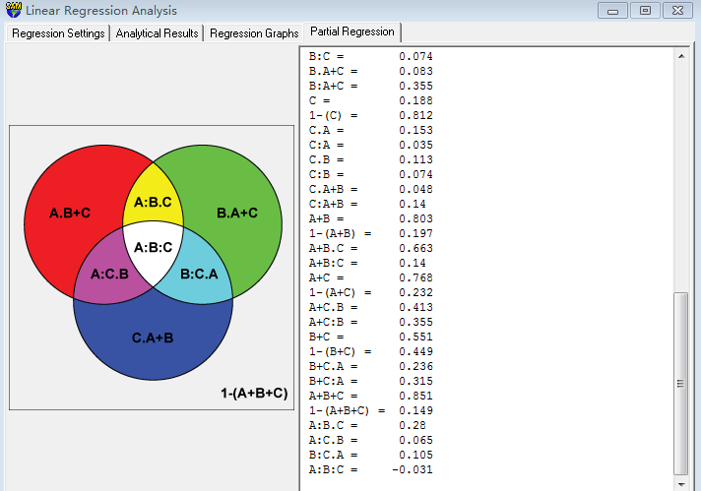

Predictor set {A}:

bio_15

bio_19

bio_3

bio_4

Predictor set {B}:

CST

HII

LUCC

PC

Predictor set {C}:

s01

s02

s03

s04

s05

s06

s07

s08

A = 0.615

1-(A) = 0.385

A.B = 0.365

A:B = 0.249

A.C = 0.58

A:C = 0.035

A.B+C = 0.3 a

A:B+C = 0.315

B = 0.438

1-(B) = 0.562

B.A = 0.188

B:A = 0.249

B.C = 0.363

B:C = 0.074

B.A+C = 0.083 b

B:A+C = 0.355

C = 0.188

1-(C) = 0.812

C.A = 0.153

C:A = 0.035

C.B = 0.113

C:B = 0.074

C.A+B = 0.048 c

C:A+B = 0.14

A+B = 0.803

1-(A+B) = 0.197

A+B.C = 0.663

A+B:C = 0.14

A+C = 0.768

1-(A+C) = 0.232

A+C.B = 0.413

A+C:B = 0.355

B+C = 0.551

1-(B+C) = 0.449

B+C.A = 0.236

B+C:A = 0.315

A+B+C = 0.851

1-(A+B+C) = 0.149

A:B.C = 0.28 d

A:C.B = 0.065 e

B:C.A = 0.105 f

A:B:C = -0.031 g